Sample Instructions – Final

Name: Kennedy Kabaso.

Strayer University.

Week 9 assignment 7

ENG 316

Technical Communications

Professor: Dennis McGeehan.

September 4, 2017

**How to Bake Sweet-Potato Fries**

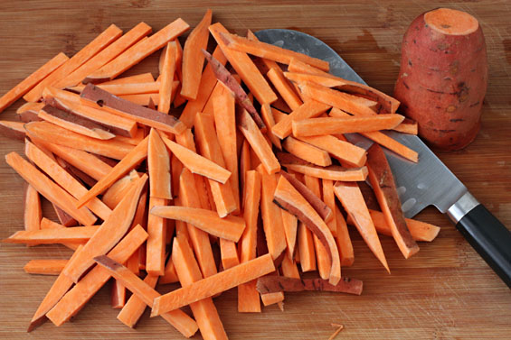Good afternoon Girl Scouts. You are welcome to the group and today you would be shown or taught how to bake some sweet Potato Fries in the kitchen. Before starting the procedure, the list of ingredients (what is needed) would be written, an instruction (how to do it) recipe on how to bake sweet potato fries would be written as well and finally, some questions would be taken from those who may need to know more. To this instructional recipe, a clean Kitchen is needed which has a Stove and a microwave.

*Cut the potatoes into 1/2″ thick strips, or to your desired thickness and length. After you are done, this is how everything looks in the picture on the right.* *This is how the baked Sweet Potato Fries looks after coming out of the oven in the above picture on the left.*

## Needed Ingredients

1. Vegetable oil for parchment
2. 2 large sweet potatoes.
3. The potatoes need to have skins on, scrubbed and cut into 4-inch sticks, each 1/2 inch thick
4. 3 large white eggs.
5. Some [Mediterranean Spice](http://www.wholeliving.com/130419/mediterranean-spice).

**Instructions**

1. Put the racks in the upper and middle positions, and turn the oven to 450 degrees.
2. Line two baking sheets with parchment paper and rub with oil.
3. Put some sweet potatoes in a microwave-safe container, cover, and microwave 2 minutes.
4. Stir gently, cover, and microwave 1 to 2 minutes more until pieces are pliable.
5. You can let it rest for 5 minutes covered; pour onto a platter.
6. In a large bowl, whisk egg whites until frothy.
7. Then add spice mix, and whisk to blend.
8. Working in batches, toss the sweet potato pieces in the seasoned egg whites, letting the excess liquid drip back into the bowl.
9. Place in a single layer on prepared baking sheets.
10. Bake for 10 minutes, then flip pieces over with a spatula. Rotate baking sheets from front to back and from one rack to the other.
11. Bake until dark golden brown, about 15 minutes.

After following the above instructions, the baked Sweet Potato Fries would look like the one in

the above shown picture. Therefore, can be served immediately and let the family enjoy the

snack.

I hope everybody have understood how to Bake some Sweet-Potato Fries and would put this into practice without any problem. Thank you very much for been attentive.

**Bibliography**

1. <https://tipjunkie.com/easy-and-delicious-healthy-baked-snack-recipes/>
2. https://www.education.com/activity/recipes/
3. <https://www.education.com/activity/article/Science_Ice_Cream/>
4. Smith-Worthington, D., Jefferson, S. (2011). Technical writing for success (3rd ed.). Mason, OH: Cengage.
5. https://www.gimmesomeoven.com/oven-roasted-sweet-potato-fries/